Pledging online is easy, safe and secure!
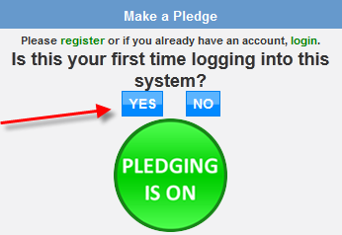

First Step: Register

Go to the site: www.giveattheoffice.org/_sccp/

At the Home page Click “Yes” to “Is this your first time
logging into the system?” so you can register.

If you registered previously you can log in and pledge or
select “I forgot my password” to reset it.

Select your agency from the list. Use the key word search to narrow the list.
Once you find your agency click “click to expand” to find your facility or department.
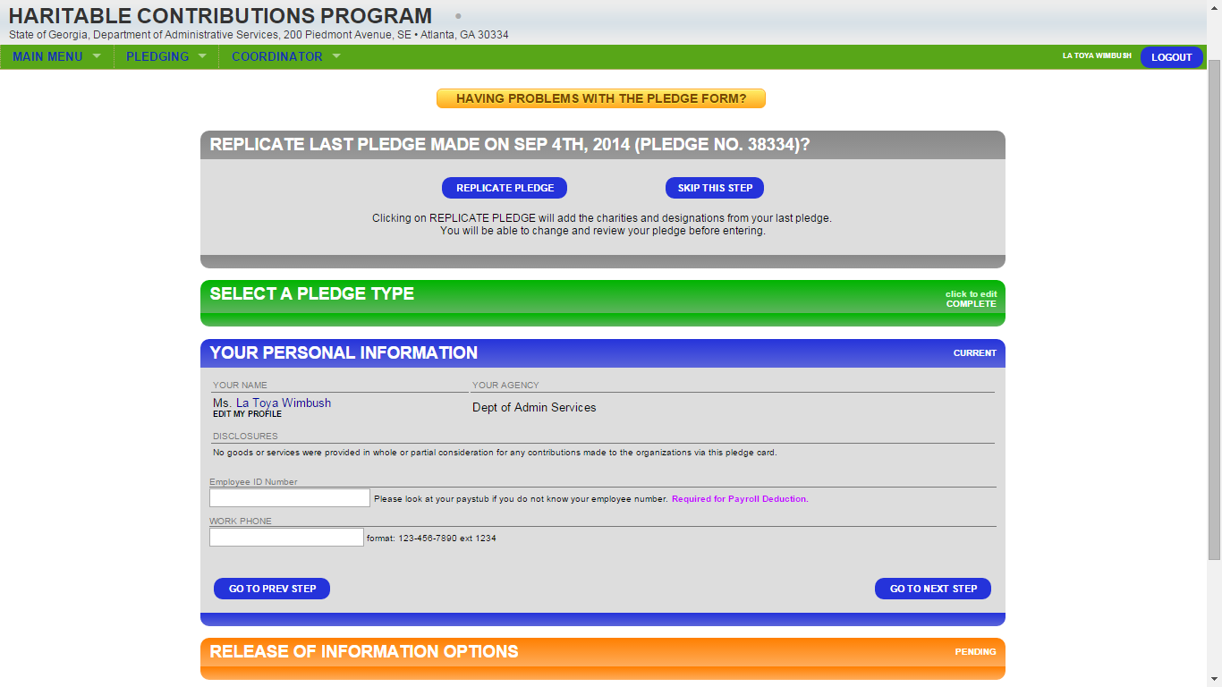

Select your State agency and location that corresponds to the code on your paystub. (1)

Complete the registration
Enter your first and last name as it appears on your paystub.
Enter your email address and create a user name and password.
You will receive a confirmation email once you click “register me”. Now you can login and make a pledge.

Next Step: Make your pledge
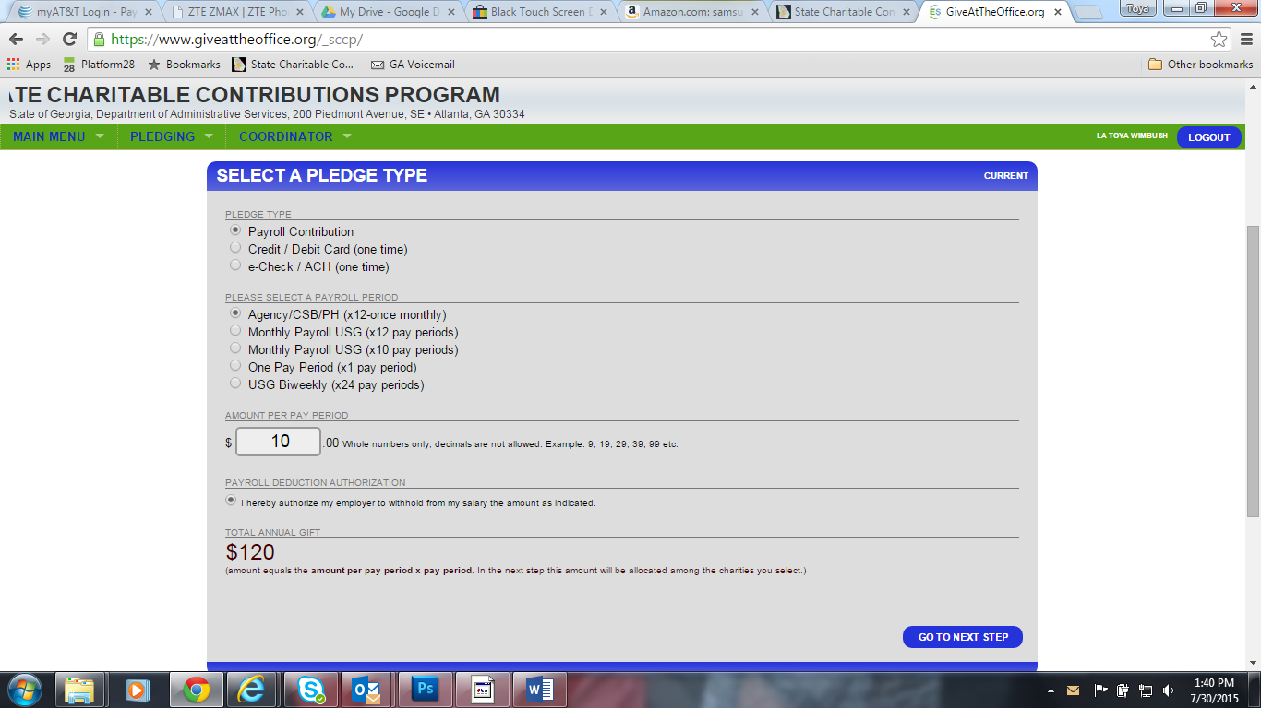

Enter your State employee ID number from your paystub

Final Step: Select Charities and Allocate your pledge
Click on the plus sign next to the charity and the selection will expand. You can visit the charities’ websites to learn more about them or you can click “Add”. Keep choosing your charities until you are ready to allocate your gift. Scroll down once you have selected your charities and enter a dollar amount next to the charities you chose.
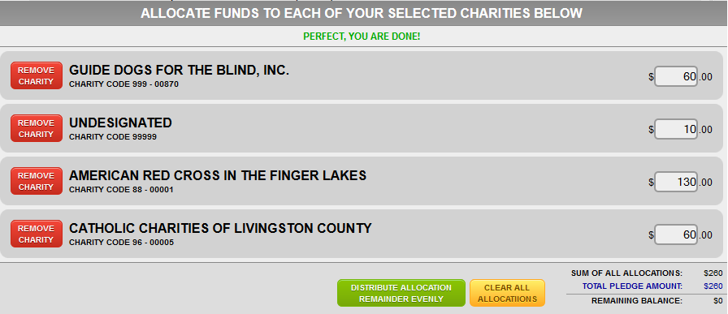

When you are finished, click “Enter Pledge”. You will receive an email acknowledgement of your pledge.

Thank you for participating in the Georgia State Charitable Contributions Program Campaign!

